Each student will complete a Power Point presentation on a racial, ethnic or religious group. This racial, ethnic or religious affiliation must be different from your own. This is your opportunity to learn more about other cultures, beliefs, practices, prejudices, and experiences. You may reference your textbook(s) for possible topics but you are not limited to these.
Students are also encouraged to select a topic of their own, but will need the instructor’s approval. You are encouraged to begin exploring your topic for this presentation early in the semester. Students must have approval for their topic from the instructor by the date of the first Test. Please submit your topic prior to this date so that approval can be granted.

Instructions for Power Point Presentation:
- Students will create a 15 – 20 slide presentation to be used for instruction on their topic.
- Notes should be added to the presentation for verbal dissemination or may be recorded as an audio presentation.
- Five (5) additional slides must be added to the end of the presentation and include 5 multiple choice questions (1 question per slide) which could be used for assessment of the material. Correct responses and explanations to each question (including explanations for incorrect responses) should be included in the notes of each slide.
- References should be included on a final slide. References must include at least:
  - 1 personal interview
  - 1 scholarly journal
  - No MORE than 1 website
- Review questions and reference slides are in addition to the 15 – 20 content slides.

Any statistics, graphs, or other information that is used from another source must be referenced and not exceed 10% of the final presentation. The information presented in this assignment should by YOUR work – copying and pasting information from other sources is considered plagiarism.

Creatively presenting your information is encouraged. Use of slide design, transitions, special graphics and inserts is highly encouraged. Bonus credit will be given for audio presentations and/or use of video in the presentation.

Presenting Text
PowerPoint presentations are meant to be a visual aide, not a written report, therefore “Less is More”. In order for your audience to listen to your presentation, you should avoid full sentences or paragraphs on the slides you present. Sentences, paragraphs, and further notes should be added at the “Notes” section at the bottom of the slide (these can be printed with slides when specified as “Notes” in the printing preferences). Slides should outline the presentation and help the audience follow key ideas. For example, look at the difference between the two slides below on the same introduction to “Project Launch”.
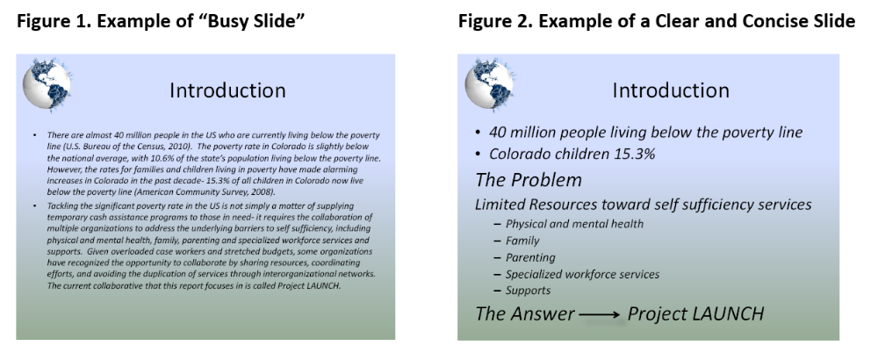

Fonts

- Avoid fonts that are difficult to read.
- Use no font size smaller than 24 point.
- Use different colors, sizes and styles (bold, underline) for impact.
- No more than 6-8 words per line
- For bullet points, use the 6 x 6 Rule. One thought per line with no more than 6 words per line and no more than 6 lines per slide
- Use dark text on light background or light text on dark background.
- To test the font, stand back six feet from the monitor and see if you can read the slide.

Graphics and Design and Color

- Keep the background consistent and subtle.
- Use only enough text when using charts or graphs to explain clearly label the graphic.
- Keep the design clean and uncluttered.
- Try to use the same style graphics throughout the presentation (e.g. cartoon, photographs)
- Limit the number of graphics on each slide.
- Check all graphics on a projection screen before the actual presentation.
- Limit the number of colors on a single screen.
- Bright colors make small objects and thin lines stand out. However, some vibrant colors are difficult to read when projected.
- Use no more than four colors on one chart.

General Presentation

- Check the spelling and grammar.
- Give a brief overview at the start - then present the information. Finally review important points.
- It is often more effective to have bulleted points appear one at a time so the audience listens to the presenter rather than reading the screen.

Rubric
This assignment is worth 100-points for being complete and submitted on time.
Power Point Presentation Rubric
Category | Points
 | 40-31 | 33-27 | 26-20 | 19-0
Quality of Information  40 points | Information clearly relates to the main topic. Each slide includes several supporting details and/or examples. Notes are well documented. | Information clearly relates to the main topic. Each slide provides 1 – 2 supporting details and/or examples | Information has little to do with the main topic | Information has nothing to do with the main topic
 | 30-25 | 21-19 | 18-13 | 12-0
Organization  30 points | Information is organized in a clear, logical way. It is easy to anticipate the type of material that might be on the next slide. 15-20 slides total | Most information is organized in a clear, logical way. One slide or item of information seems out of place. | Some information is logically sequenced. An occasional slide or item of information seems out of place. | Information is not only disorganized but inaccurate
 | 10-9 | 8-7 | 6-5 | 4-0
Mechanics  10 points | No grammatical, spelling or punctuation errors | Almost no grammatical, spelling, or punctuation errors | Many grammatical, spelling, or punctuation errors | Numerous grammatical and punctuation errors
Sources  10 Points | All sources are accurately documented in APA format | All sources are accurately documented, but a few are not in APA format | Some sources are not accurately documented | Numerous sources are not documented accurately and there is not a format used
Presentation  10 Points | Slide design, transition, use of special features | Slides are well formatted with some design | Simple formatting and presentation | Minimal effort for presentation

